WealthOps — DevOps / EKS Journey So Far
1. Application containerization
We started with the WealthOps Flask application and containerized it using Docker.
Architecture:
WealthOps Flask Application
│
▼
Docker
│
▼
Docker Image
wealthops:latest
Dockerfile:
FROM python:3.13-slim
WORKDIR /app

COPY requirements.txt .

RUN pip install --no-cache-dir -r requirements.txt

COPY . .

EXPOSE 5000

CMD ["python", "app.py"]

Interview explanation
"I containerized the WealthOps Flask application using Docker, creating a lightweight Python-based container image that could run consistently across environments."

2. Local Kubernetes with Kind
Before moving to AWS, we validated the application on Kubernetes locally using Kind running through Docker Desktop.
Architecture:
Docker Desktop
│
▼
Kind Kubernetes Cluster
│
└── wealthops namespace
│
├── WealthOps Pod
└── PostgreSQL Pod
We created Kubernetes resources including:
- Deployment
- Service
- PostgreSQL Deployment
- PostgreSQL Service
- PVC
- Kubernetes Secrets
- ConfigMap
- Ingress
This allowed us to validate the application on Kubernetes before introducing AWS.
Interview explanation
"I first validated the containerized workload on a local Kubernetes cluster using Kind. This allowed me to validate deployments, services, persistent storage, configuration and ingress before moving the workload to AWS."

3. PostgreSQL persistence
We didn't use an ephemeral PostgreSQL container.
We created:
PostgreSQL
│
▼
PersistentVolumeClaim
│
▼
PostgreSQL data
This taught us the Kubernetes storage model:
Pod
↓
Volume Mount
↓
PVC
↓
Persistent Storage
For our local environment, this was sufficient for the POC.
We already identified that a more production-oriented AWS architecture should eventually move PostgreSQL to Amazon RDS rather than keeping the database inside the application cluster.

4. Kubernetes configuration management
We separated configuration from the application image.
We created:
ConfigMap
│
├── DB_HOST
├── DB_PORT
├── DB_NAME
└── UPSTOX_BASE_URL
And sensitive configuration:
Secret
│
├── DB_USER
├── DB_PASSWORD
├── UPSTOX_CLIENT_ID
└── UPSTOX_CLIENT_SECRET

Then injected them into the WealthOps Deployment:
envFrom:
- configMapRef:
name: wealthops-config

- secretRef:
name: wealthops-secret
Interview explanation
"I separated non-sensitive configuration using ConfigMaps and sensitive application credentials using Kubernetes Secrets instead of baking configuration into the Docker image."

5. Kubernetes Ingress + TLS
Locally we introduced NGINX Ingress.
The flow became:
Browser
│
▼
https://wealthops.local:8443
│
▼
NGINX Ingress
│
▼
WealthOps Service
│
▼
WealthOps Pod
We also configured a TLS certificate:
wealthops.local.crt
wealthops.local.key
│
▼
wealthops-tls Secret
The local certificate was self-signed, so the browser showed the expected "Not secure" warning.
Interview explanation
"I implemented Kubernetes Ingress routing and TLS termination locally to understand the same networking model that we would later replace with an AWS Load Balancer in EKS."
6. AWS ECR
We then moved the Docker image into Amazon ECR.
Our repository:
Amazon ECR
│
└── wealthops
└── latest
The workflow:
Docker Build
│
▼
Local Docker Image
│
▼
Amazon ECR
We authenticated Docker to ECR using AWS CLI and pushed the image.
Example conceptually:
docker build -t wealthops-wealthops:latest .

docker tag wealthops-wealthops:latest \
<account>.dkr.ecr.us-east-1.amazonaws.com/wealthops:latest

docker push \
<account>.dkr.ecr.us-east-1.amazonaws.com/wealthops:latest

\

That meant the old image was being pushed.
We diagnosed it by inspecting the images and running the container to verify whether the latest application changes existed.
Correct workflow became:
Build
↓
wealthops-wealthops:latest
↓
TAG SAME IMAGE
↓
ECR
↓
EKS
Interview value
This is actually a useful troubleshooting story:
"I encountered a container image tagging issue where the build image and ECR-tagged image were different. I verified the image contents locally, corrected the tagging workflow, pushed the correct image to ECR, and restarted the Kubernetes deployment."

10. Understanding our IAM separation
This was one of the most important architectural decisions.
Initially our AWS user:
GitLabuser
had ECR permissions:
AmazonEC2ContainerRegistryFullAccess
AmazonEC2ContainerRegistryPowerUser
That means the identity was effectively designed around:
GitLab CI/CD
↓
ECR
It did not have EKS permissions. confirmed that when:
aws eks list-clusters returned: AccessDenied

11. Created separate EKS provisioning role
Instead of simply turning our GitLab/ECR user into an administrator, we created:
WealthOpsEKSProvisioner ROle
The role currently has: AdministratorAccess
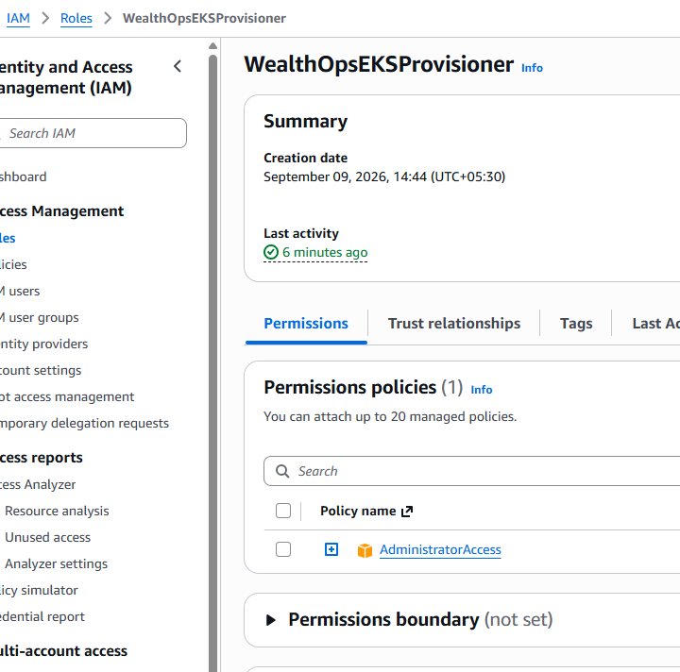
This is being used as a temporary provisioning role for our POC, not as the application's runtime identity.
Architecture:
GitLabuser
│
└── ECR permissions
│
▼
ECR
GitLabuser:
│ AssumeRole
▼ WealthOpsEKSProvisioner
│ └── EKS infrastructure provisioning
We also added permission allowing GitLabuser to perform:
sts:AssumeRole
against:
WealthOpsEKSProvisioner
Verified role assumption
aws sts assume-role \
--role-arn arn:aws:iam::<account>:role/WealthOpsEKSProvisioner \
--role-session-name WealthOpsEKSSetup
The important concept is:
GitLabuser
│
│ AssumeRole
▼
WealthOpsEKSProvisioner
│
▼
AWS infrastructure
This means our EKS infrastructure operations are performed through the provisioning role, rather than simply giving the ECR user permanent administrator permissions.
13. EKS cluster configuration
We created: eks-cluster.yaml
with the intended architecture:
wealthops-eks
│
├── EKS Control Plane
│
└── wealthops-ng
│
├── Managed Node 1
└── Managed Node 2

